Wilson Basketball Bag
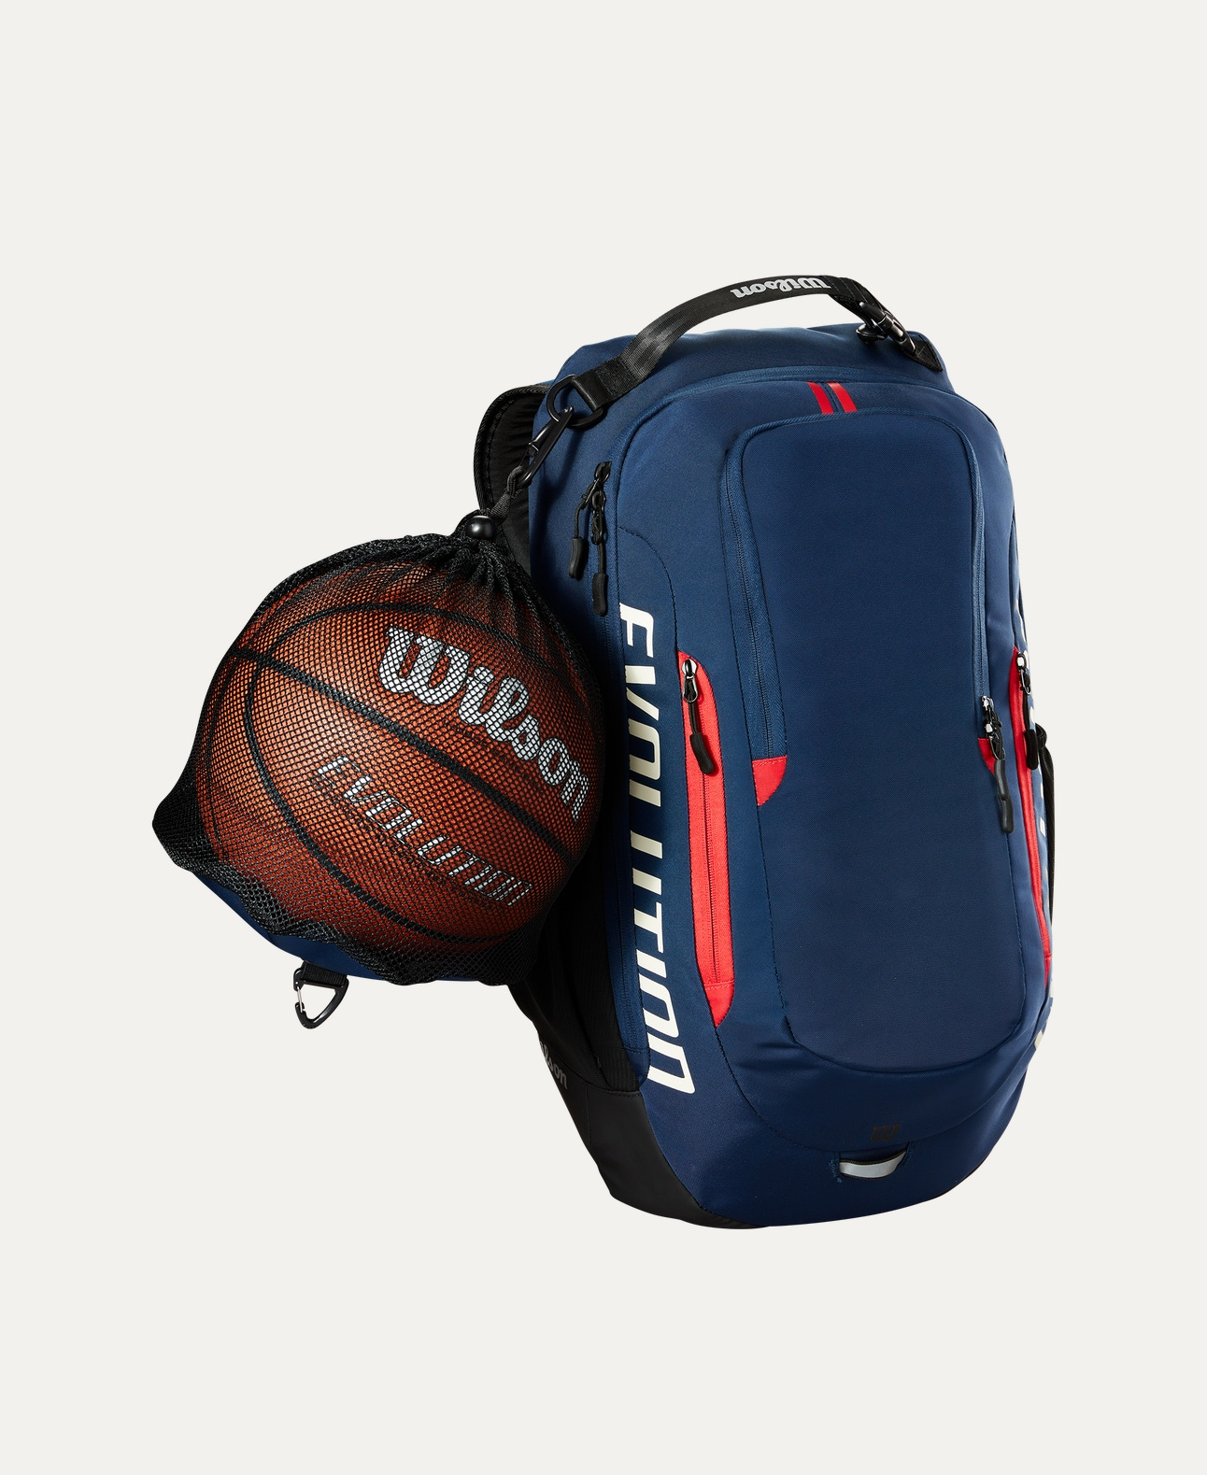
Price: Approximately Rs 15,555
Introduction
The Wilson Basketball Bag is designed to carry basketballs conveniently while offering durability and comfort. It is an ideal accessory for players, coaches, and teams who need an easy and reliable way to transport their equipment.

Product Overview
This Wilson Basketball Bag provides secure storage for basketballs with a lightweight and practical design. It is suitable for daily practice, matches, and team training sessions.

About the Brand
Wilson is a globally trusted sports brand known for producing high-quality sports equipment and accessories. Wilson bags are designed to meet professional standards of durability and functionality.

Key Features
- Designed for easy basketball storage
- Lightweight and easy to carry
- Strong zipper or drawstring closure (model dependent)
- Comfortable shoulder strap or handles
- Durable construction for regular use

Design & Build Quality
The bag features a simple yet sporty design with reinforced stitching. Its ergonomic structure ensures comfortable carrying while maintaining shape during use.

Storage & Capacity
Designed to carry one or multiple basketballs depending on the model, making it suitable for individual players as well as team use.

Material & Durability
Made from high-quality polyester or mesh fabric, the Wilson Basketball Bag is resistant to wear and tear and suitable for indoor and outdoor use.

Ideal For
- Basketball players
- Coaches and trainers
- Schools and sports academies
- Practice sessions and matches

Care Instructions
- Clean with a damp cloth
- Do not overload beyond capacity
- Store in a dry place
- Avoid contact with sharp objects

Product Specifications
- Brand: Wilson
- Product Type: Basketball Bag
- Material: Polyester / Mesh Fabric
- Carry Style: Shoulder strap / Hand carry
- Usage: Training & Match Use

Product Summary
The Wilson Basketball Bag offers a practical and durable solution for carrying basketballs safely. With its lightweight design and reliable build quality, it is an excellent choice for players and teams at all levels.

Thank you

